Tips to promote your book on Facebook

Facebook is one of the most powerful social media networks in the world. If you use it intelligently, you’ll get incredible results! So, read these 9 things to know how to achieve these results:
- Remember that personal page isn’t a good thing. You want to promote a BOOK, not yourself. So, the first thing you should do is to create fan page. There you will be able to post a photo of your book cover and its brief review. If you have a personal page, you have to become friends with all of your fans, so you see all the news from them. Moreover, a personal page has a friend limit. A fan page offers a one-way connection between you and fans, they see your updates, but you don’t see theirs. With such a page you can send e-mails to fans without having to be "friends" with them.
- Let’s dot the i’s and cross the t’s. Social networks give us basic materials that can function in many different ways but only we can figure out how to use them in all possible methods. The interface of Facebook has a few imperfections, so searching for the most comfortable and efficient type of page can take some time. Experiment with the site.
- Be sure to include the URL for your website. Also you can type individual address of your page.
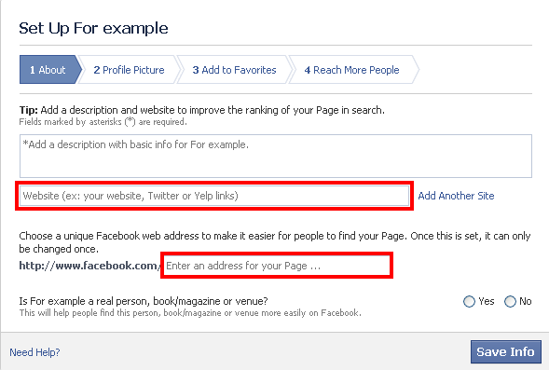
If you didn’t fill this line from the very beginning, you can choose ‘Edit page’ later. Click on the ‘Page Info’ and find the line ‘Website’:
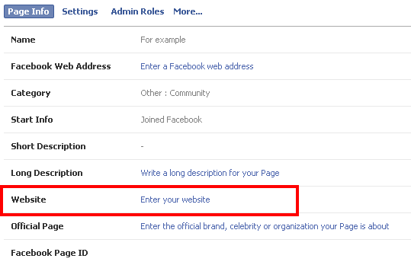

- Don’t forget that this page is not about personal news or superfluous information. Keep all those fans that read it in mind when you post updates or photos.
- One of the main items is fan base. The more fans you have, the easier it’s for you to promote your book. To become your fan user only needs to click ‘like’. However, don’t delude yourself with hopes that they see your updates. There was created an algorithm which sorts hundreds of posts available for a person by priorities. So, only a few of these posts will be shown in news feed of user.
- So, we discovered that Facebook chooses what to show, but how can you burst through all the posts and get on the higher level? The answer is… fans. Yes, again. They click likes, share a post and comment it. If a fan doesn’t make one of those actions regularly, the algorithm will come to conclusion that he is not really a fan and user won’t see your content again or he will but it will be a rare thing.
- Difference in time is one of the disadvantages; because of it you can’t have enough time to please all the fans. For example, you post messages in the morning but half or even 60-80% of your fans sleeps in beds at this time and don’t see your posts. In this case algorithm excludes them from your fans. However, you can use timer for some posts and they will be seen even when you’re busy or snoring in your bed.
- Don’t forget to use different types of posts. It can be photo, link or short video. Some fans click on links, eye of others can be drawn by questions, and some of them pay attention to photos.
- The last useful thing is this mate: https://www.facebook.com/PromoteMyBook

Good luck and keep these points in your mind, then you’ll succeed!

